Technical Design for Gui Manager

Revision History

Issue | Date | Person | Reason
0.1 | April 10, 2002 | Chuck Chow | Initial version
1.0 | April 12, 2002 | Chuck Chow | Reviewed by team and released

Description

Introduction
The Gui Manager Singleton controls all the GUI elements of the game. It controls loading and switching of the Scrooby Projects, creates three sub managers, the FE screen manager, InGame screen manager and SaveLoad Screen manager. Each Sub manager creates, initializes, and destroys its own screens. Each screen will be semi-autonomous, responding to buttons events via a userinputhandler object. Screens will know which screens follow and proceed them, and generate events such as MENU_TOGGLE, and MENU_SELECT for the sounds system, etc.

Requirements
The Gui Manager must display the following screens as per the flow diagrams.

The FE Flow Single Player:
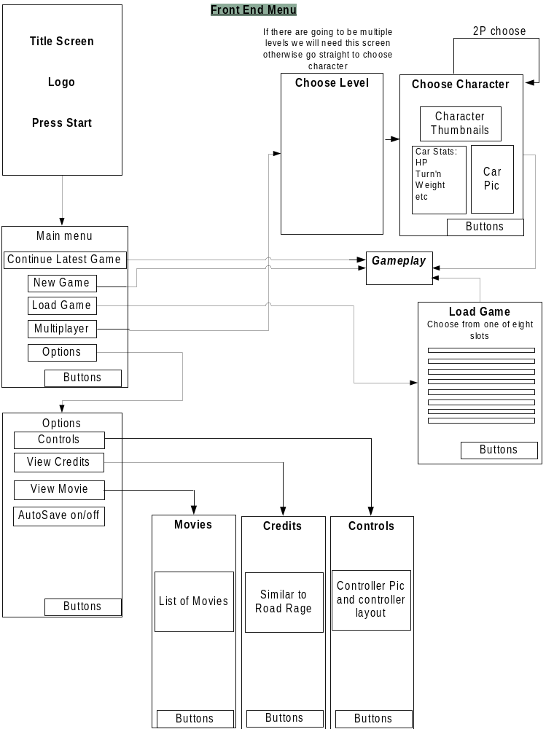

FE Flow Multiplayer:
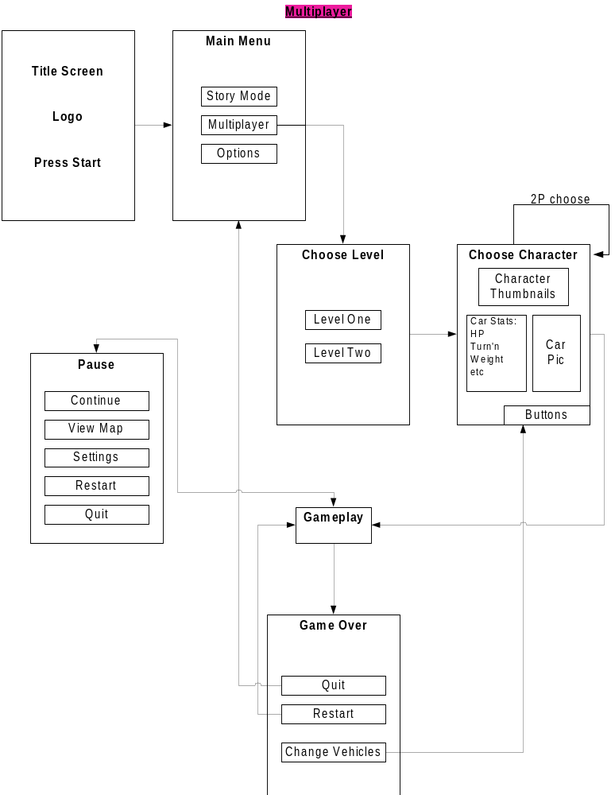

Pause Menu Single Player:
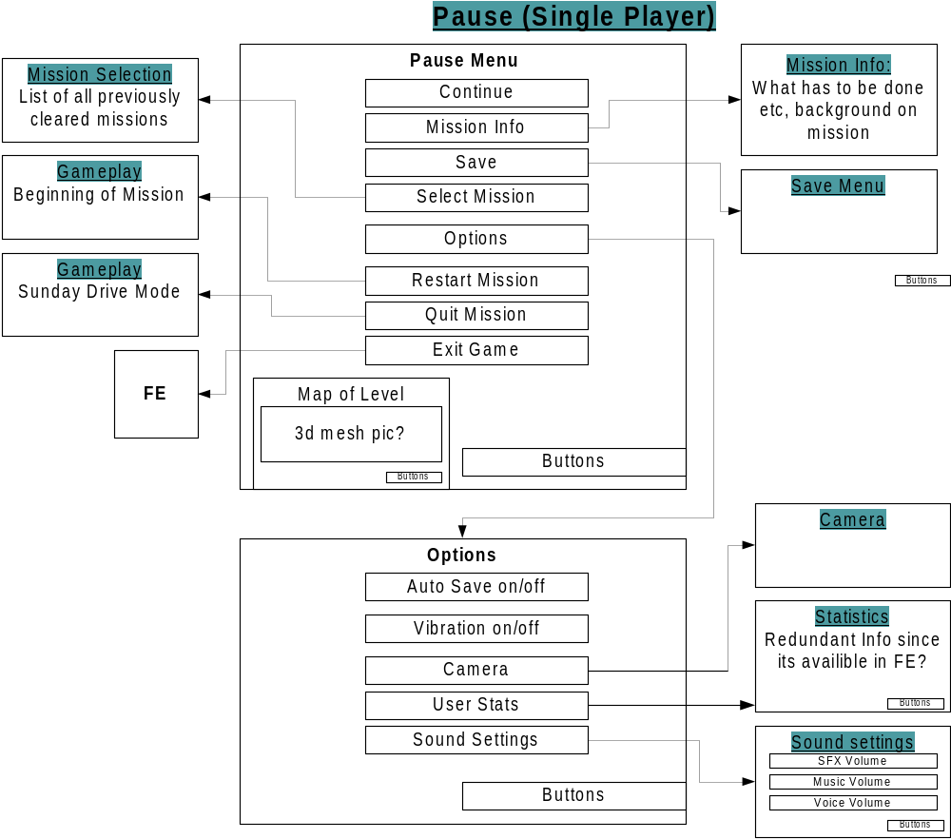

Multiplayer:
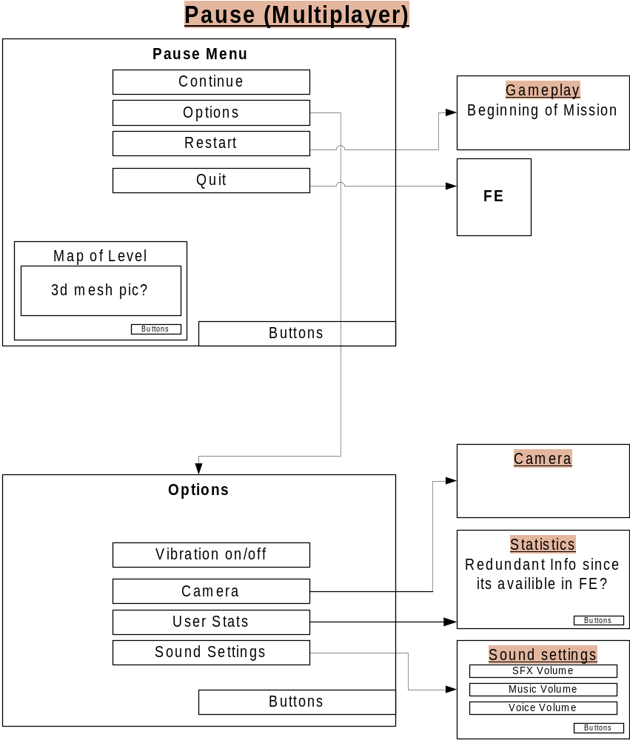
HUD:
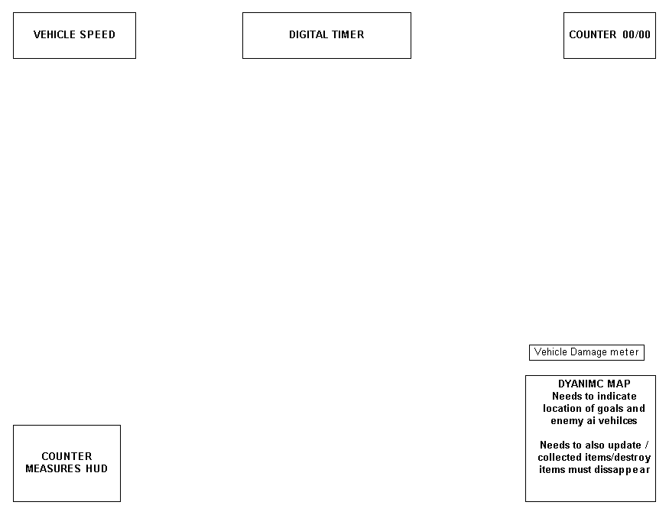

Speed- Displays vehicle’s speed
Digital Timer- Timer for missions
Counter- Displays the user progress for mission with collectables/destructables
Counter Measures indicator-Displays the status of user available counter measures
Vehicle Damage indicator-Displays the current vehicles durability

Dynamic Map- Displays the current map of Level, this stays on screen when user is in car and on foot, where as some or all of HUD elements disappear while user is on foot. The Nav manager updates/controls this HUD element.

ADDITIONAL REQUIREMENTS
- Gui manager must also clean up resources when context changes
- Provide an interface for the Presentation Manager to trigger in-game overlays

References

- Talked to Joe and Shawn about FE flow, HUD elements, and PM flow.
- Talk to Darren about sound system, wants Gui Manager to register events for menu changes and selections.
- Talked to Cary about Memory Card Manager and Camera Manager interface.
- Talked to Travis about controller messages. Based on last years guiuserinputhandler.cpp
- Talked to Darryl about Mission Manager and Movie player interface.

Technical Design

Relationships
The Gui Manager interacts with:
- Memory Card Manager
- Player Avatar Class
- Camera Manager
- Sound Manager
- Mission Manager
- Controller Manager
- Presentation Manager

Some sample interactions:

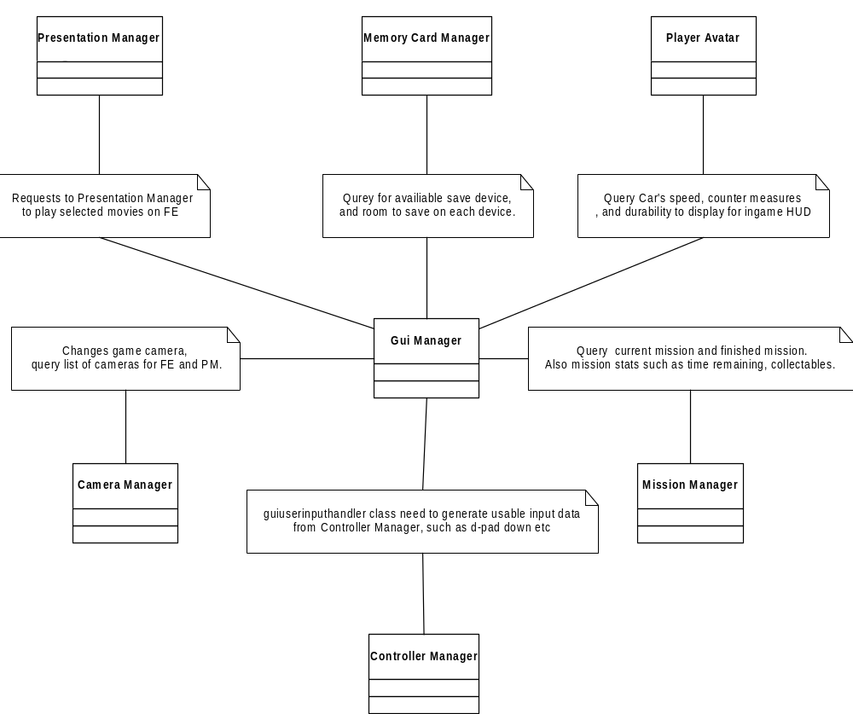

Interface

enum EnumScreen
{
TITLE,
MAIN_MENU
OPTIONS,
MOVIES_SELECTION,
CREDITS,
LOADGAME,
SAVEGAME,
NULL
};

enum EnumSubManagerID
{
FE,
INGAME,
LOADSAVE
}

class GUIScreen
{
public:
void Update ();
void HideElement(int ElementID);
void ShowElement(int ElementID);
GUIScreen* GetHandle();
EnumScreen GetName();

};

class GUISubManager
{
public:
void Init();
void Shutdown();

void DisplayScreen(EnumScreen screen);
void Resume ();
private:
EnumScreen currentscreen;

};

struct ScreenRequest
{
EnumSubManagerID SubmanagerID;
EnumScreen screen;
};

class GUIManager : public Manager
{
public:
void Init( );
void Shutdown( );
void Udpate(context_type context);
void ChangeScreen(EnumSubManagerID submanagerid ,EnumScreen screen);
GUISCREEN* GetHandle(EnumScreen screen);

private:

context_type currentcontext,previouscontext;
EnumSubManagerID currentsubmanager,previoussubmanager;
EnumScreen currentscreen;
ScreenRequest nextscreen;

};

Component Class Diagrams

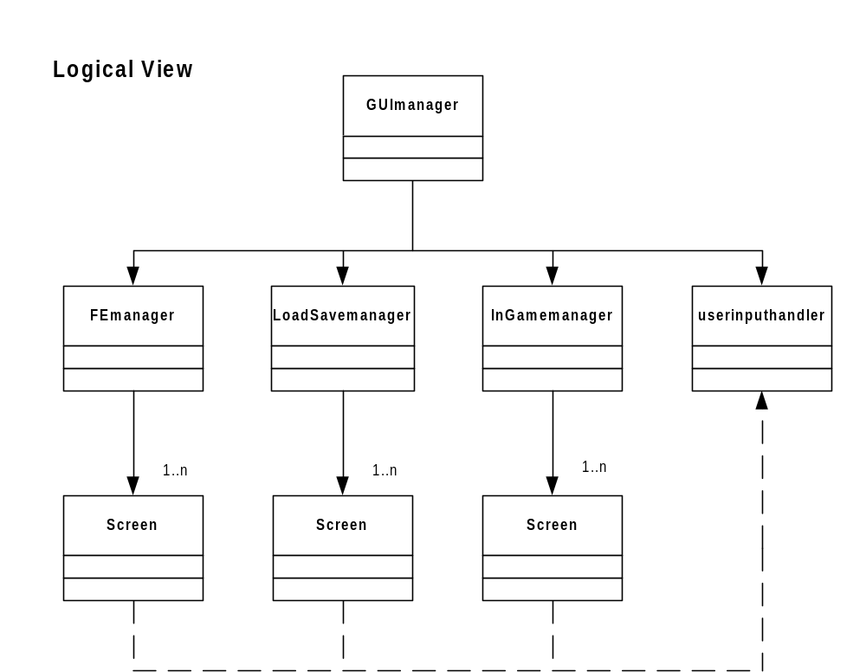

Guimanager:

- Creates the 3 submanagers and the userinputhandler object
- Calls the Load Manager to load and unload the scrooby projects
- Determines which screen and submanager is active at any given time.
- Determines when to call the submanager’s init( ) and shutdown ( ) to create and destroy screens.

Submangers

- Init ( ) creates all the screens controlled by this submanager
- Remembers which of its screens was last active.
- Calls the Screen’s update ( ).

Screens
- polls the userinputhandler object for controller messages
- Does all the work.

Use Cases
